MONDAY | TUESDAY | WEDNESDAY | THURSDAY | FRIDAY
THE GALLERIA WILL BE CLOSED 2/18 IN OBSERVANCE OF PRESIDENTS’ DAY  2/5 – MAKING NO-BAKE NUTELLA COOKIES  2/20 – WEAR YOUR FAVORITE HOODIE  2/28 – COOKIE CHILI |  |  |  | 1  Jib Jab Lunch    Oh Wow! Museum
4    Noon Fitness Class - TFF  Wendy’s Lunch | NATIONAL NUTELLA DAY 5    Nature Photo Exhibit – MC Park  Butler Museum – Guided Tour | 6    Trumbull Mobile Meals  Dunkin Donut Snack | 7  Tilt Studio - Arcade    Trumbull Fam Fitness - Swim | NATIONAL PIZZA DAY 8    Mall Walk & Aquarium  Pizza Hut Lunch
11    Coloring for Grownups - Library  Applebee’s Lunch | 12    Veteran’s Outreach  Wedgewood Lanes - Bowling | 13  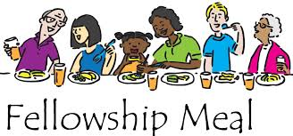  Trumbull Mobile Meals  Panera Bread Snack | 14    Trumbull County Dog Warden  VALENTINES DAY PARTY | 15  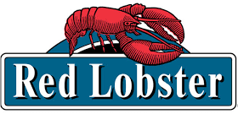  Jewels of Winter – MC Park  Red Lobster Lunch
CLOSED 18    PRESIDENTS’ DAY | 19  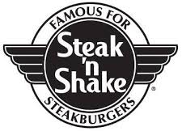  Trumbull Fam Fitness – Swim  Steak N’ Shake Lunch | HOODIE HOO DAY 20  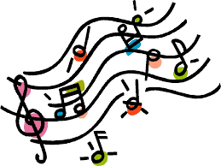  Trumbull Mobile Meals  Music at Noon – Butler Museum | 21  Art Fair – Canfield Library    Dairy Queen Snack | 22    Regal Cinema Movie  Botanical Mornings – MC Park
25    Pat Catan’s Craft Class  Dunkin Donuts – Coffee Talk | 26  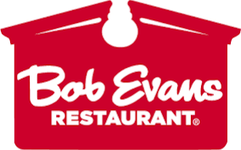  Veteran’s Outreach  Bob Evans - Lunch | 27    Trumbull Mobile Meals  Wedgewood Lanes - Bowling | NATIONAL CHILI DAY 28  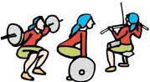  Noon Fitness Class - TFF  Tilt Studio – Choice Activity
GATEWAYS GALLERIA FEBRUARY 2019

